**Лабораторная работа №4 по курсу**

**«Базовые компоненты интернет-технологий»**

Выполнил: Саврасов П.А. Группа РТ5-31

**Описание задания лабораторной работы.**

Разработать программу, реализующую работу с файлами.

**Текст программы на языке С#.**

Класс Program:

**using** System;  
**using** System.Windows.Forms;  
  
**namespace** LR4  
{  
    /// <**summary**>  
    /// Class with program entry point.  
    /// <**/summary**>  
    **internal** sealed class Program  
    {  
        /// <**summary**>  
        /// Program entry point.  
        /// <**/summary**>  
        [STAThread]  
        **private** static void **Main**(string[] args)  
        {  
            Application.**EnableVisualStyles**();  
            Application.**SetCompatibleTextRenderingDefault**(**false**);  
            Application.**Run**(**new** MainForm());  
        }  
          
    }  
}

Класс MainForm:

**using** System;  
**using** System.Collections.Generic;  
**using** System.ComponentModel;  
**using** System.Data;  
**using** System.Drawing;  
**using** System.Linq;  
**using** System.Text;  
**using** System.Threading.Tasks;  
**using** System.Windows.Forms;  
**using** System.IO;  
**using** System.Diagnostics;  
**namespace** LR4  
{  
    **public** partial class MainForm : Form  
    {  
          
        **public** MainForm()  
        {  
            **InitializeComponent**();  
                                  
        }  
        string *Path*;  
        List<string> *Words* = **new** List<string>();  
          
        #**region** Timers  
        **TimeSpan** *currentTimer* = **new** **TimeSpan**();  
  
        **private** void **RefreshTimer**()   
        {    
            *textTimer*.Text = *currentTimer*.**ToString**();  
            *textTimer2*.Text=*currentTimer*.**ToString**();  
        }  
  
          
        void **MainFormLoad**(object sender, EventArgs e)  
        {  
            **RefreshTimer**();  
        }  
        #**endregion**  
  
        #**region** Scan  
        void **TakePathToFileClick**(object sender, EventArgs e)  
        {  
            OpenFileDialog FileDialog = **new** OpenFileDialog();   
            FileDialog.Filter = "текстовые файлы|*.txt";  
            **if**(FileDialog.**ShowDialog**() == **DialogResult**.*OK*)  
            {  
                **this**.*Path*=FileDialog.FileName;  
                **this**.*textBox1*.Text=**this**.*Path*;  
            }  
        }  
          
        void **StartScanFileClick**(object sender, EventArgs e)  
        {  
            **if**(*Path*!=**null**)  
            {  
                **if**(!**this**.*checkBoxMulti*.Checked) *Words*.**Clear**();  
                Stopwatch St1 = **new** Stopwatch();  
                string FileFilling = File.**ReadAllText**(**this**.*Path*);  
                St1.**Start**();  
                string[] Words2 = FileFilling.**Split**(' ','.',',','!','?','/','\t','\n');  
                **foreach** (string strTemp **in** Words2)   
                {  
                    string str = strTemp.**Trim**();  
                    **if** (!**this**.*Words*.**Contains**(str))  
                    {  
                        **this**.*Words*.**Add**(str);  
                    }  
                }      
                St1.**Stop**();  
                *textTimer*.Text=St1.Elapsed.**ToString**();  
                **if**(**this**.*checkBox1*.Checked)  
                {  
                    **this**.*listBox1*.Items.**Clear**();  
                    **this**.*listBox1*.**BeginUpdate**();  
                    **foreach**(string str **in** *Words*)  
                    {  
                        **this**.*listBox1*.Items.**Add**(str);  
                    }  
                    **this**.*listBox1*.**EndUpdate**();  
                }                      
                **else**  
                    **this**.*listBox1*.Items.**Clear**();  
                **this**.*textBox2*.Text = *Words*.Count.**ToString**();  
            }  
            **else**   
            MessageBox.**Show**("Chose scaning file!","Error!",**MessageBoxButtons**.*OK*,**MessageBoxIcon**.*Error*);          
        }  
        #**endregion**  
          
        #**region** Empty Elements  
        void **TextBox2TextChanged**(object sender, EventArgs e)  
        {  
      
        }  
        void **CheckBox1CheckedChanged**(object sender, EventArgs e)  
        {  
      
        }  
        void **TextBox1TextChanged**(object sender, EventArgs e)  
        {  
                      
        }  
        void **MatchingWordTextChanged**(object sender, EventArgs e)  
        {  
      
        }  
        void **ListBox1SelectedIndexChanged**(object sender, EventArgs e)  
        {  
      
        }  
        void **CheckBoxMultiCheckedChanged**(object sender, EventArgs e)  
        {  
      
        }  
  
        #**endregion**  
          
        #**region** Matcher  
        void **FindMatchClick**(object sender, EventArgs e)  
        {  
            **bool** Match=**false**;  
            Stopwatch St2 = **new** Stopwatch();  
            St2.**Start**();  
            **foreach**(string str **in** **this**.*Words*)  
            {   
                **if**(String.**Equals**(str,**this**.*MatchingWord*.Text)==**true**) Match=**true**;  
                  
            }  
            St2.**Stop**();  
            *textTimer2*.Text=St2.Elapsed.**ToString**();  
            **switch**(Match)  
            {  
                    **case** **true**:{MessageBox.**Show**("Match is found.","Match");break;}  
                    **case** **false**:{MessageBox.**Show**("Match is not found.","Match");break;}  
            }  
        }  
  
        #**endregion**  
    }  
}**Результаты выполнения программы, экранные формы:**

Главная форма:

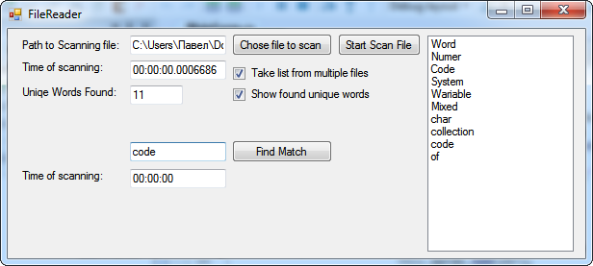

Сообщение об ошибке в случае отсутствия пути к файлу:

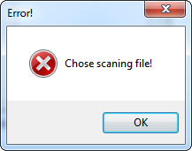

Сообщение о результате поиска:

